

**UNIVERSITY OF PETROLEUM & ENERGY STUDIES**

**Dehradun**

**CONTINOUS INTEGRATION**

**AND**

**CONTINOUS DELIVERY**

**Experiment**

**Name: Rithik Choudhary**

**Course: B. TECH CSE DevOps (2018-22)**

**Roll no.: R171218084**

**Sapid: 500069261**

**Experiment-4**

**Static Code analysis using SonarQube**

**Install sonarqube**

**Step 1: First we have to download the sonarqube from the official website**

**https://www.sonarqube.org/success-download-community-edition/**

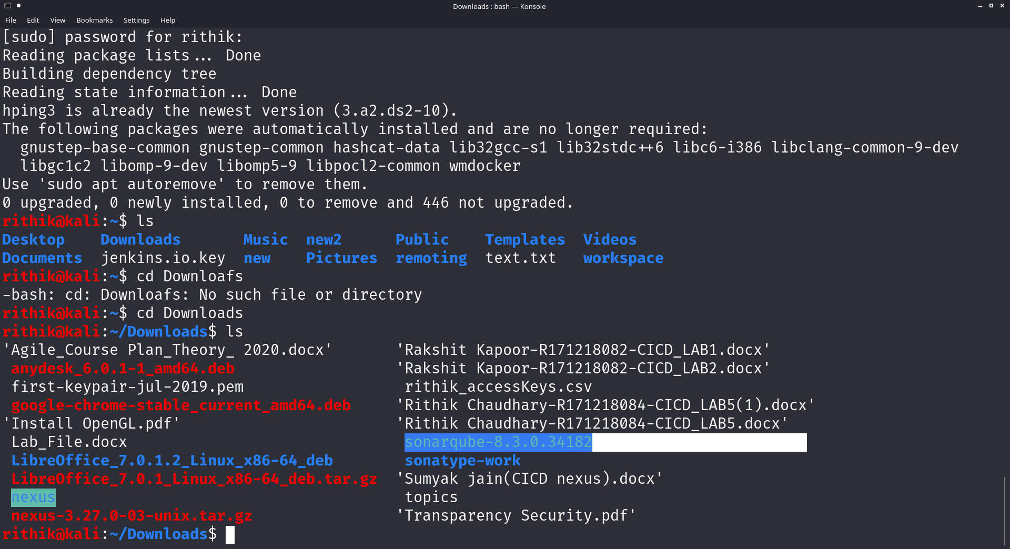

**Step 2: To run the sonarqube we have to give it all read write and append permission to use the port**

**so to give the permission we use this command.**

**>sudo chmod -R 777 <filename>**



**Step 3: Now we need to set the port open from firewall to allow the sonarqube to run its application**

**so, we will use ‘ufw’ tool**

**> sudo ufw allow 9000**

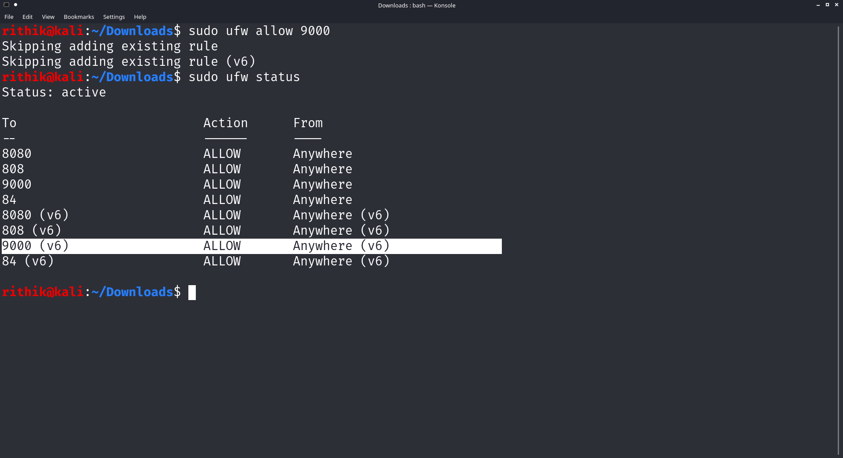

**To check the status of ports we use**

**> sudo ufw status**

**Step 4: Now we are all set to run the sonarqube filename**

**first go to the right place**

**> cd** *sonarqube-8.3.0.34182*/bin/linux-x86-64

**Here we will find a file named sonar.sh**

**so we need to run that file**

**> ./sonar.sh start**

**to check the status**

**> ./sonar.sh status**

